**DAILY ONLINE ACTIVITIES SUMMARY**

|  |  |  |  |  |  |  |  |  |
| --- | --- | --- | --- | --- | --- | --- | --- | --- |
| **Date:** | 29/05/2020 | | | | | **Name:** | CHANDANA S | |
| **Sem & Sec** | 4th SEM ‘A’ SEC | | | | | **USN:** | 4AL18CS016 | |
| **Online Test Summary** | | | | | | | | |
| **Subject** | | Operating Systems(18CS43) | | | | | | |
| **Max. Marks** | | 30 | | **Score** | | | 25 | |
| **Certification Course Summary** | | | | | | | | |
| **Course** | Cloud Computing with AWS | | | | | | | |
| **Certificate Provider** | | | Great Learning | | **Duration** | | | 3 Hours |
| **Coding Challenges** | | | | | | | | |
| **Problem Statement:** 1. Write a Java program to Find size of the largest ‘+’ formed by all ones in a  binary matrix.  2. To find total number of sub arrays which start and end with the same  element. | | | | | | | | |
| **Status:** Completed | | | | | | | | |
| **Uploaded the report in Github** | | | | | YES | | | |
| **If yes Repository name** | | | | | https://github.com/chandushivalingareddy/lockdown-coding | | | |
| **Uploaded the report in slack** | | | | | YES | | | |

**Online Test Details:**

The online test was from module 2 which was about the Multi-threaded Programming, Process Synchronization. There were 30 questions and the duration was 45 minutes. The questions were optimal and were easy. The score that I got in the test is 25/30.

**Snapshot:**

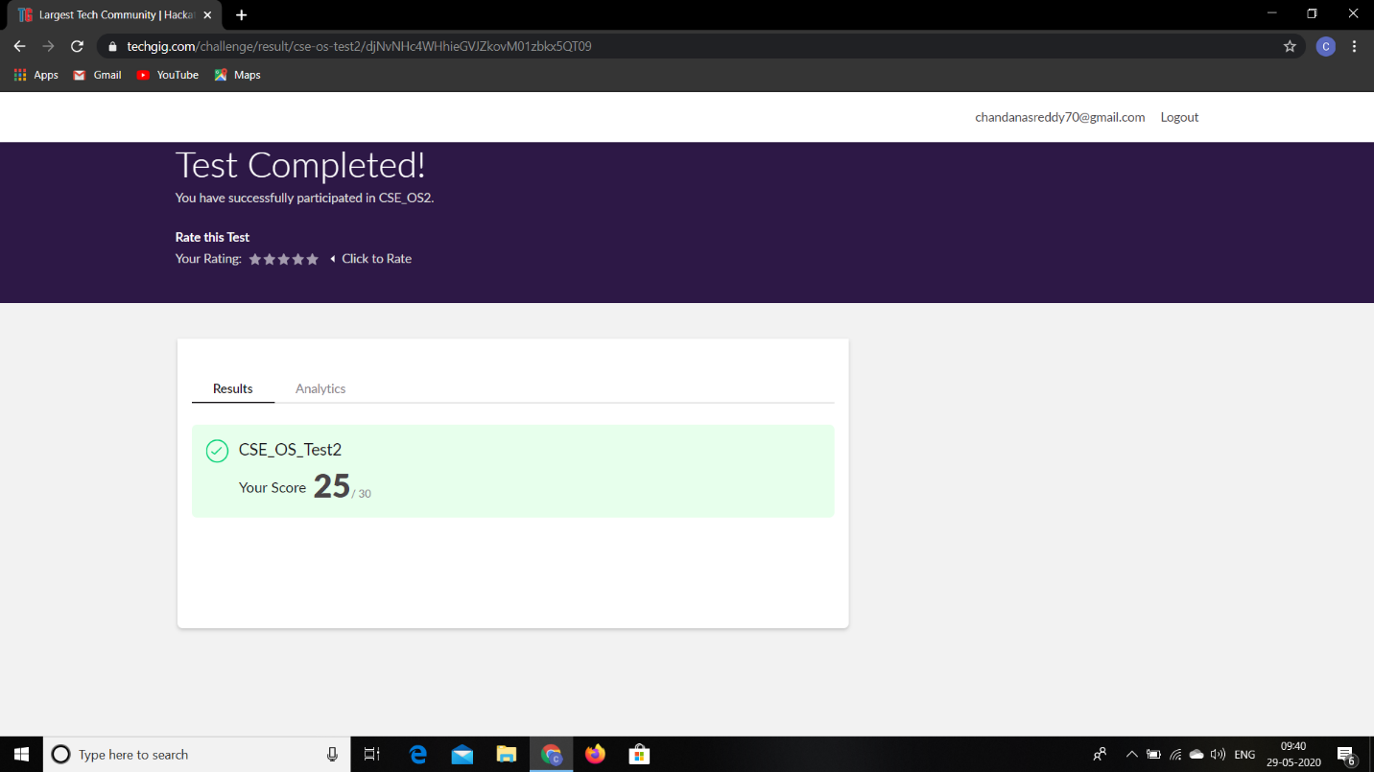

**Certification Course Details:**

**Name of the course**: Cloud Computing with AWS

**Certificate Provider**: Great Learning

Today I went through the four modules of the course that explained about Compute,Organization and IAM.

Module 1: Core Building Blocks, Abstraction, AWS Console.

Module 2: Compute-Elastic Compute Cloud or EC2.

Module 2a: AWS EC2 Step 3-Advance Features Part 1.

Module 2b: AWS EC2 Step 3-Advance Features Part 2.

Module 3: How to SSH in to an EC2 Instance.

Module 4: Load Balancing, Fault Tolerance and Cloud Watch.

**Snapshot:**

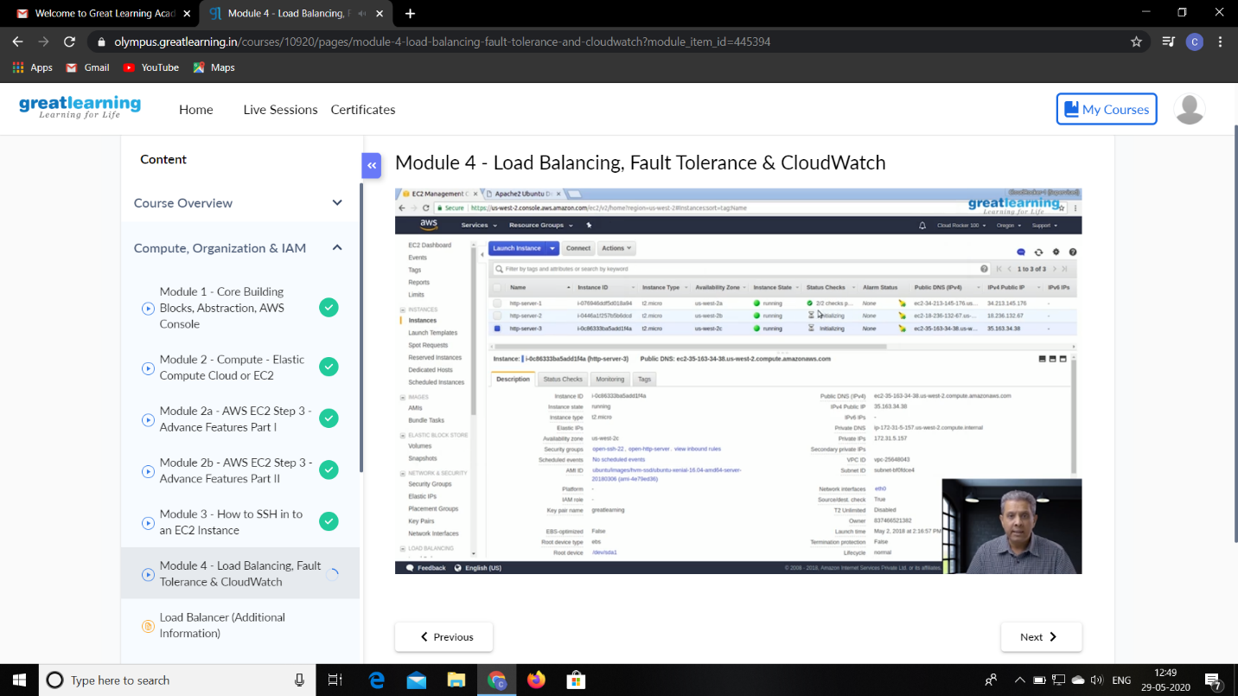

**Online Coding Details:**

Problem 1: Write a Java program to Find size of the largest ‘+’ formed by all ones in a binary matrix.

**Snapshot:**

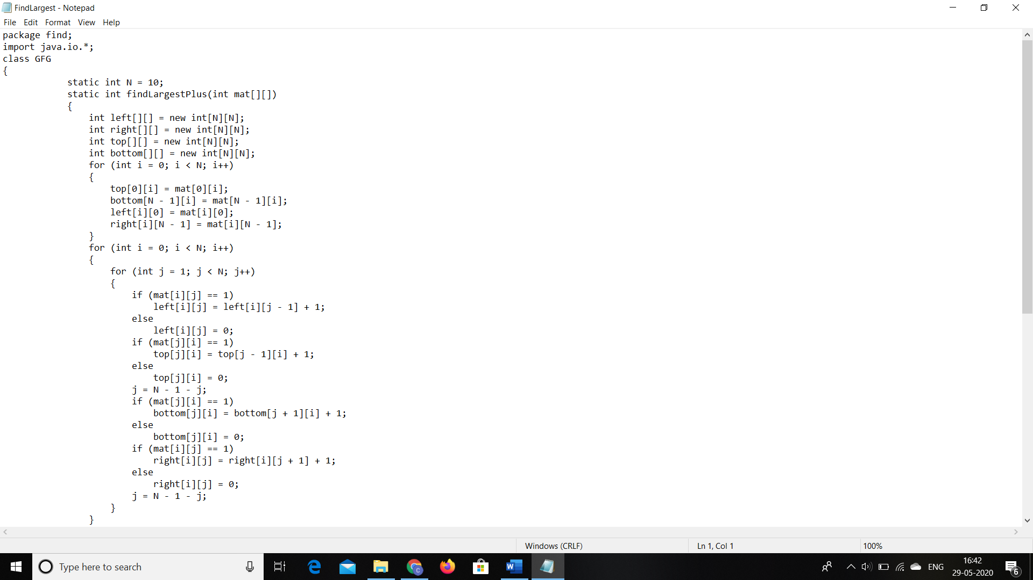

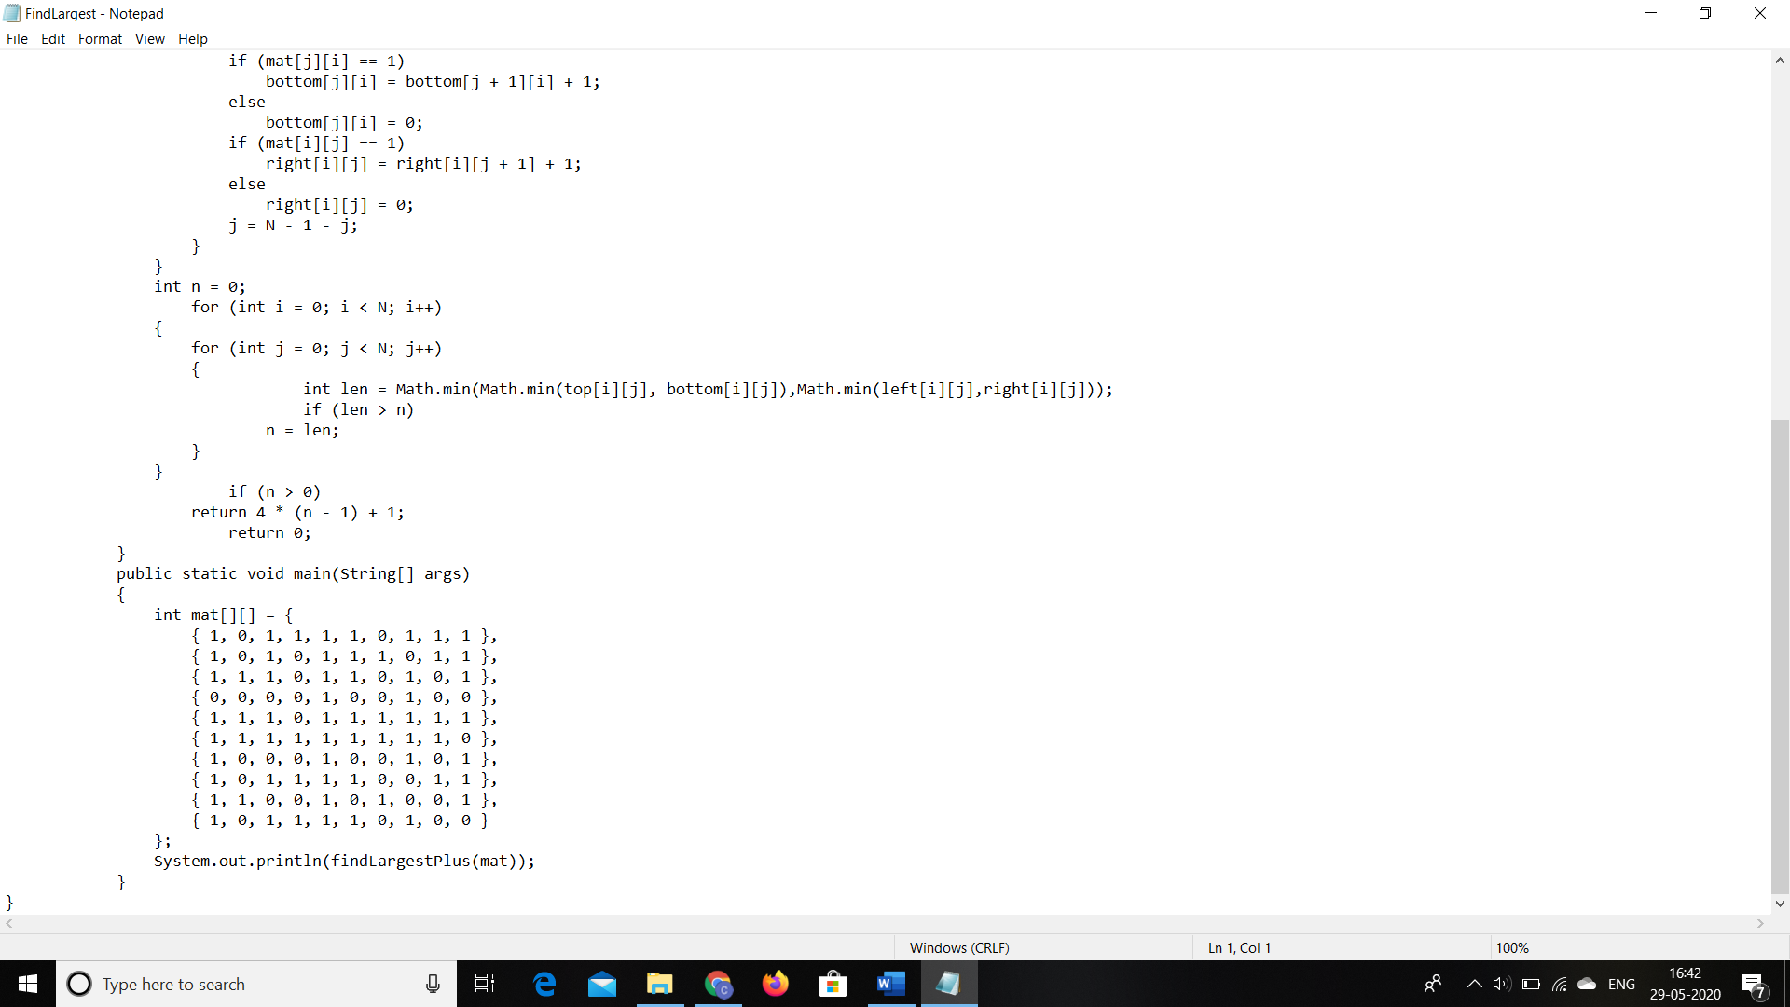

Problem 2: To find total number of sub arrays which start and end with the same element.

**Snapshot:**

